暨南大学本科实验报告专用纸

课程名称 数值计算实验 成绩评定
实验项目名称 Computing Problems 指导教师 Liangda Fang
实验项目编号 02 实验项目类型 验证型 实验地点 N116
学生姓名 学号
学院 信息科学技术学院 系 计算机系 专业
实验时间2021年 10 月 23 日上午10:30～ 12:10

Ⅰ、Problem
Let f(x) = e ^{2x} and the interval to be [ 1, 1].
1. Write a program generating the Newton’s divided difference formula;
2. Use the program to generate a degree n polynomial with evenly spaced points and Chebyshev points for n = 10, 20 and 40;
3. Plot the polynomials for the above types (see Figure 3.8);
4. By sampling at a 0.05 step, create the empirical interpolation errors for each type, and plot a comparison (see Figure 3.11).

Ⅱ、Algorithm summary
Using polynomial approximation data is a way of data compression. Given some data points, it may be very complex to accurately describe the functions of these points, but the function value y corresponding to point x can be easily and nearly calculated by interpolation polynomial. In polynomial interpolation, Newton difference formula and Chebyshev node are common methods. The following describes the principles of these two algorithms.

Firstly, we introduce the main theorem of polynomial interpolation, which is the important foundation of polynomial interpolation.

- Main theorem of polynomial interpolation
Let (x1,y1), . . . , (xn,yn) be n points in the plane with distinct xi . Then there exists one and only one polynomial P of degree n − 1 or less that satisfies P(xi ) = yi for i = 1,...,n. Newton’s divided differences give a particularly simple way to write the interpolating polynomial. Given n data points, the result will be a polynomial of degree at most n − 1.

That is to say, the interpolation polynomials obtained by Newton's difference quotient formula are the same as those obtained by other algorithms. The polynomials obtained by interpolating the known points are unique.

- Newton’s divided difference fomular
First, some definitions need to be clear: Suppose that the data points come from function f(x).Our purpose is to let the polynomial interpolate those points(x₁, f(x₁)), •••, (x_{n},f(x_{n})).In this method ,the coefficients of the x^{n-1} term of the unique polynomial is f[x₁•••x_{n}] .

With this definition, the following somewhat remarkable alternative formula for the interpolating polynomial holds, called the Newton’s divided difference formula:
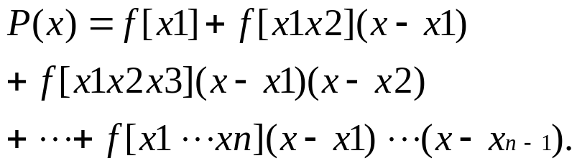
Besides, the coefficients f [x1 . . . xk] from the above definition can be recursively calculated as follows.

List the data points in a table:
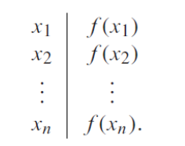
Then define the divided differences, which are the real numbers:
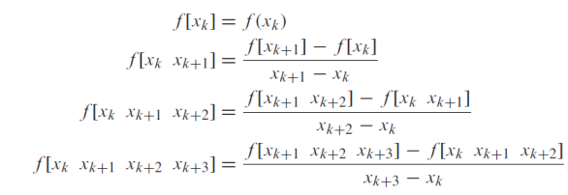
And so on. We need to be clear about that :
- the unique polynomial obtained from the above-mentioned Newton difference formula interpolating (x1,f (x1)), . . . , (xn,f(xn))
- the coefficients of the unique polynomial f[x1...xn] can be calculated as the analogy steps.

Notice that the divided difference formula gives the interpolating polynomial as a nested polynomial. It is automatically ready to be evaluated in an efficient way.
After simplification, the interpolation polynomials calculated by Newton's difference formula are as follows:
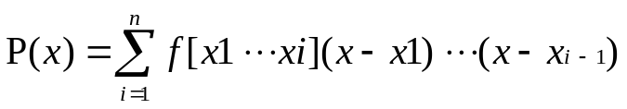
The calculation process of Newton's difference formula is as follows:

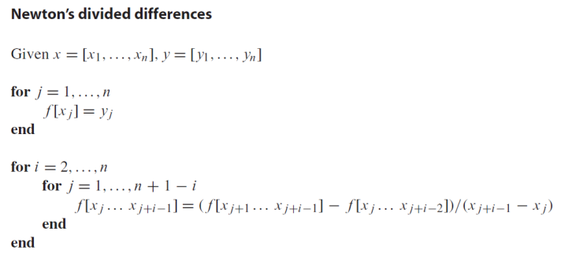
- Interpolation Error
The error of interpolation polynomial is f(x)-P(x), the difference between the original function that provided the data points and the interpolating polynomial, evaluated at x. The following theorem gives the interpolation error formula, which gives the error bounds of interpolation polynomials.
Theorem: Assume that P(x) is the (degree n − 1 or less) interpolating polynomial fitting the n points (x1, y1), . . . , (xn, yn). The interpolation error is:
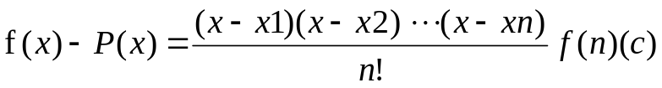
where c lies between the smallest and largest of the numbers x,x1, . . . , xn.

- Chebyshev interpolation
It is very common to use the point of average distribution as the base point X of interpolation polynomial, but it is proved that the selection of base point spacing has a great influence on the interpolation error. Chebyshev interpolation is a specific optimal method to select the distance between points. The motive of Chebyshev interpolation is to improve the control of the maximum value of interpolation error as follows on the interpolation interval.
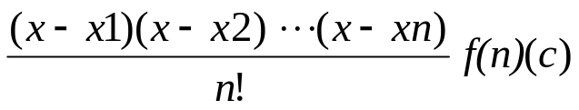
If we fix the interval to be [−1,1]:
That is to select the choice of real numbers −1 ≤ x1, . . . , xn ≤ 1 that makes the value of 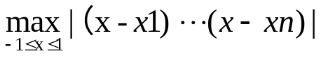 as small as possible. Actually:
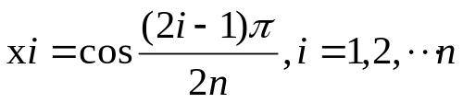
and the minimum value is 1/2n−1. In fact, the minimum is achieved by the following formula: (Tn(x) denotes the Chebyshev polynomial)
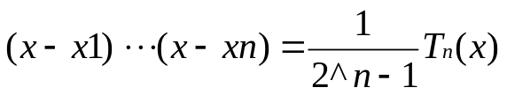
In general, The minimum value of 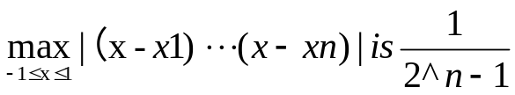. When xi’s are the Chebyshev nodes, the enumerator achieves the minimum value.

Ⅲ、Experimental procedures
Step1: Define variable n ;
Step2: Define function nest to evaluates polynomial from nested form using Horner‘s Method ;
Step3: Define function newtdd to computes coefficients of interpolating polynomial ;
Step4: Using function nest and newtdd to generate a degree n polynomial with evenly spaced points and Chebyshev points for n = 10, 20 and 40;
Step5: Plot the polynomials for the above types ;
Step6: By sampling at a 0.05 step, create the empirical interpolation errors for each type, and plot a comparison.

Ⅳ、Result analysis
实验结果+分析

Ⅴ、Experimental summary
实验总结

Appendix : Source code

附上代码

